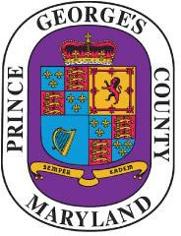

Prince George’s County

NOTICE OF PUBLIC MEETING
LGBTQIA+
WORKGROUP
will meet on
Friday, July 19, 2024
2:00 p.m.

VIRTUAL MEETING
Topic: Task Forces - Workgroups - LGBTQIA+
Join Zoom Meeting
https://mypgc.zoom.us/j/81815890572
Meeting ID: 818 1589 0572
Passcode: 117928
---
One tap mobile
+13017158592,,81815890572# US (Washington DC)
8778535247,,81815890572# US Toll-free
---
Dial by your location
• +1 301 715 8592 US (Washington DC)
• 877 853 5247 US Toll-free
Meeting ID: 818 1589 0572
Find your local number: https://mypgc.zoom.us/u/kfWUTMCsh

For more information, please contact:
Sandra Eubanks, HHSPS Committee Director
saeubanks@co.pg.md.us

