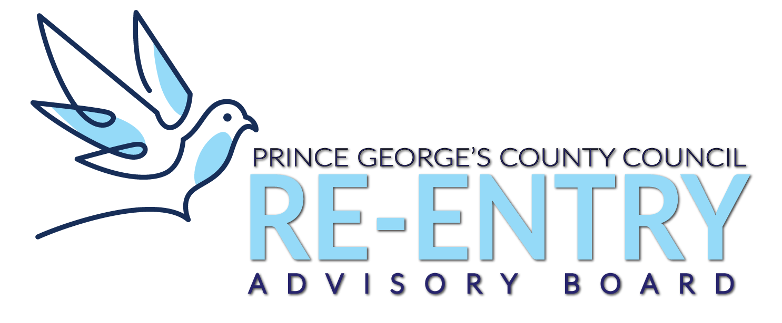

Prince George’s County Re-entry Advisory Board
Virtual Meeting

Agenda

September 16, 2020

- House Rules & Virtual Procedures
- Welcome

- Review of Minutes & Agenda Overview

- Overview of CB-028-2020 | Re-entry Employment Incentive Program

- Survey Summary Overview

- Broadcast Re-Entry Video

- Presentation from Adams House @ The Bridge Center (Dr. Somerville)

- Public Comments

- Closing & Next Meeting Date

