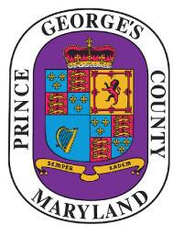
Prince George’s County

NOTICE OF PUBLIC MEETING

The
PRINCE GEORGE’S COUNTY
CLIMATE ACTION COMMISSION

will meet on

Friday, October 16, 2020

1:00 P.m.
The meeting will be live streamed, and may be viewed at the following link:
https://pgccouncil.us/LIVE
To join the virtual meeting, or to submit Questions/Concerns please email:

Kenneth Battle - jkbattle@co.pg.md.us
and/or
Shirley Anglin- smanglin@co.pg.md.us

