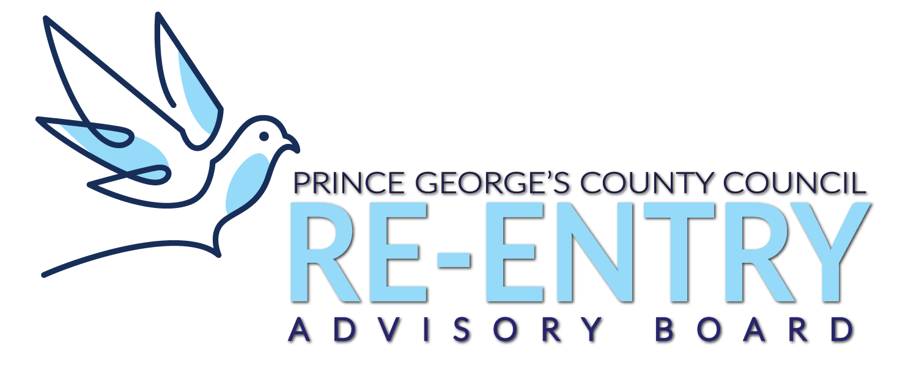

Prince George’s County Re-entry Advisory Board
Virtual Meeting

Agenda

November 20, 2020

- Welcome & Agenda

- Minutes Review & Approval

- Introduction of Speaker

- Mr. Rahim Jenkins - former Director of the District of Columbia Department of Corrections/ Nationally Known Re-Entry Facilitator/ Youth Advocate

- Public Comments

