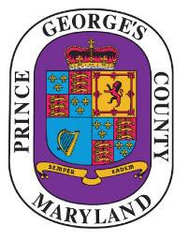
Prince George’s County

NOTICE OF PUBLIC MEETING

The
Responsible Legacy Task FOrce

will meet on
Friday, OCTOBER 2, 2020

10:00 A.m.
The meeting will be live streamed at the following link for all who wish to view the meeting:
https://pgccouncil.us/LIVE
To join the virtual meeting, please email
HWStone@co.pg.md.us and/or LCFerguson@co.pg.md.us

Submit Questions/Concerns:
Howard Stone
HWStone@co.pg.md.us and/or
Lochelle Ferguson LCFerguson@co.pg.md.us

